

Figure 27.1 Potential locations of leak after Roux-en-Y gastric bypass; at the gastro-jejunostomy, gastric pouch, proximal Roux limb staple line, gastric remnant and jejuno-jejunostomy

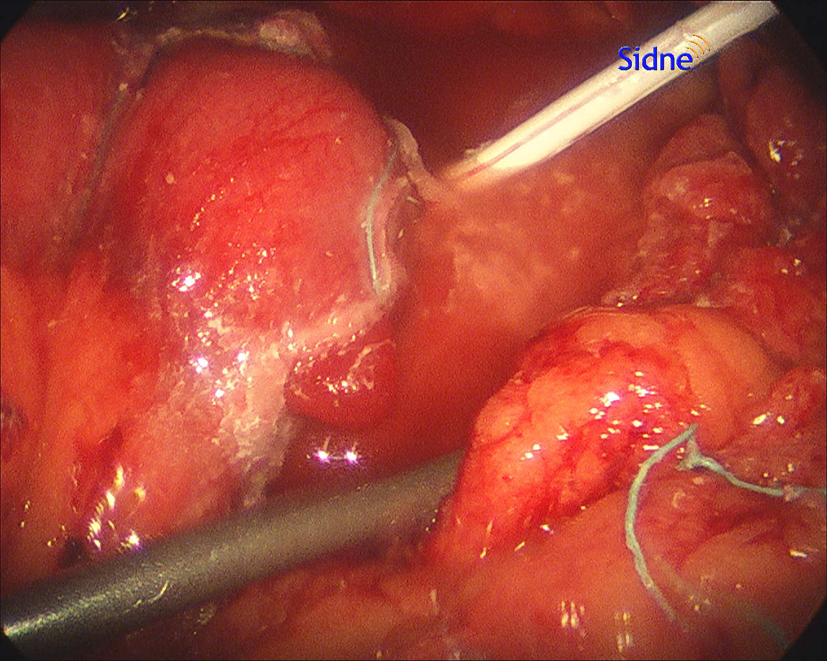

Figure 27.2 Intraoperative findings of leak: fluid collection adjacent to the staple line, free intraperitoneal air, and leakage of contrast outside the gastric pouch or gastro-jejunostomy. The drain is placed near the collection.